 | 2016 Summer Vacation Travel Evaluation Study  - Overseas travel destination satisfaction | Institute | Sejong Univ. Tourism Industry Research Lab.
 |  | Responsible Head | Kim, Hyung-Gon, Head / Ph.D /  Prof. in Graduate school
 |  | Inquiry | Kim, Min-Hwa, Researcher / Ph.D
 | ‣ Released on Oct. 24, 2016  ‣ Total 7 pages | E-mail | kimmh@consumerinsight.kr
<Joint-project by Sejong Univ. Tourism Industry Research Lab. & Consumer Insight>

Overseas summer vacation, low cost - high satisfaction guaranteed Japan
⦁ 1st place Japan had 27% of Total visited with good reasons
⦁ 3 strong European, Spain ∙ Italian ∙ France, cost high but high satisfaction
⦁ China ∙ Philippines ∙ Vietnam, many complaints from low price package
⦁ Big possibility lies in Singapore ∙ Taiwan
⦁ Okinawa of Japan & Hunan of China have high satisfactions

Sejong University Tourism Industry Research Lab. and travel research specialized firm, Consumer Insights, asked total 25,729 adults about how and where they spent the summer vacation in and out of country during the last June and August. Among them, 19% (4,860 people) went to overseas travel, and they were asked to where they have mainly traveled and to evaluate the travel destination for 'richness of travel resources', 'comfort of travel environment' and 'experienced satisfaction'. Among the 45 countries, where at least 1 person traveled, 17 countries had 60 or more samples in size (Hawaii ∙ Guam ∙ Saipan were accounted as separate country unit). By comparing them, it was possible to know where was the best summer vacation spot and what kinds of advantages ∙ disadvantages they have.

□ Spain took 1st place in Overall satisfaction: Overall satisfaction was calculated by summing 'how much satisfied with' and 'how much intend to recommend to others' for the country where spent the summer vacation. The average of the entire overseas travel at 724 points (1000-point scale), which was much higher than domestic at 644 points. By traveled country, Spain (793 points) ranked first, followed by Hawaii (788 points) at second place, Italy (773 points) at third place, France (770 points) at fourth place and Japan (769 points) at fifth place, in order. All three European countries as world tourism superpower, Spain ∙ Italy ∙ France were included in the top ranks, and they shared the common points in long-distance, long period of time, high cost and high satisfaction.

Among Asian countries, Japan and Singapore only entered into the upper-middle level but most were pushed to the bottom ranks. The four countries (China, Hong Kong, Philippines, and Vietnam) at the lowest ranks in 600 points range are common overseas summer vacation destinations (from 2nd to 7th at top) of Korean people. They are typical low-cost in close-range regions where Koreans visited a lot at inexpensive price but satisfaction was a disappointing level.

<Table 1> 17 Countries Evaluation

□ Hawaii took 1st place in Travel Resource Attractiveness: 'Travel Resource Attractiveness' evaluates how rich was the travel destination in five aspects of playing, eating, seeing, shopping & resting. The average of the entire overseas was 67 points (100-point scale), which is much higher than the domestic average of 60.3 points. But that was a natural result as much as seeking exotic things than domestic by investing a lot more time and money.
Of the 17 countries, Hawaii (73.3 points) took the first place, followed by United States ∙ France (72.9 points) at tied-second place by a narrow margin. Subsequently, Australia (71.3 points) and Singapore ∙ Japan (71.1 points) followed after. The three European countries as long-distance & high-cost destination, along with North America has received a rating of more than average.
On the other hand, all of the Asian countries except Japan ∙ Singapore were below the average, while China, Philippines and Vietnam were pushed down to the lowest ranks. That is not because their travel resources are poor but because there is no travel products, with which travelers can enjoy the resources properly. China in almost all aspects including playing, eating, shopping & resting, Philippines in eating & seeing, and Vietnam in playing & seeing, were found to be relatively poorer.
Top ranked Hawaii had higher evaluations in playing & shopping, while United States in eating & shopping and France in seeing, had higher evaluations.

□ Japan took first place in Travel Environment Comfortableness: Travel Environment Comfortableness indicates whether the travel destination's condition allowed travel resources to be enjoyed without stress. Transportation, High cost/Unreasonable price, Cleanliness/hygiene, Convenience facility, Safety/Public security and Language/Local culture were evaluated for how comfortably enjoyed in each of the six aspects. The average of the entire overseas was 62.9 points (100-point scale), which was a similar score with domestic (63.5 points). Although cause and content of stress would be different while traveling, the strength was not different between domestic and overseas.
Japan ranked first with 72.2 points, followed by Guam (72.0 points) at second place, Singapore (70.9 points) at third and Taiwan (68.1 points) at 4th, in the order. Unlike satisfaction and attractiveness, Asian developed countries and resorts such as Guam ∙ Saipan had risen to the top ranks. When the summer vacation is focused on recreation rather than sightseeing, it is better to select a short-distance travel destination, which is well-developed. Among top ranks, Japan in High cost/Unreasonable price & Cleanliness/hygiene, Guam in Transportation and Singapore in Safety/Public security, had particularly high evaluations.
On the other hand, European countries with top ranks in the attractiveness of resources, had poor evaluation. They were ranked at lower-middle as Italy at 15th, France at 12th and Spain at 9th. Travelers invested a lot of time and money to enjoy attractive travel resources, but those were not the place where they can spend time with comfortable mind.
Philippines was the country with the highest stress from travel, followed by China, Italy, Vietnam and Thailand. Philippines made travelers uncomfortable in Transportation, High cost/Unreasonable price & Cleanliness/hygiene, while China in Language/Local culture and Italy in Convenience facility & Safety/Public security, made travelers uncomfortable.

□ The more cost, the higher satisfaction: The relationship between travel costs and the overall satisfaction were confirmed [Figure 1]. There was a clear tendency with higher cost burden destination bringing higher satisfaction. The destinations requiring a lot of time and money because of far distance, as well as difficulty in access had high satisfactions. From the time you decide to pay a lot of costs, self-suggestion for satisfactory trip could have started.
In the place for highest travel expenses, United States, Italy and Spain were in the order from the highest, while Asian regions such as Taiwan, Japan, the Philippines and Vietnam required cheaper travel costs. When looking into the relationship between the cost and satisfaction, the clear thing is that there is no low satisfaction place while expensive. In order not to be dissatisfied, it seems to spend a lot of travel cost first.

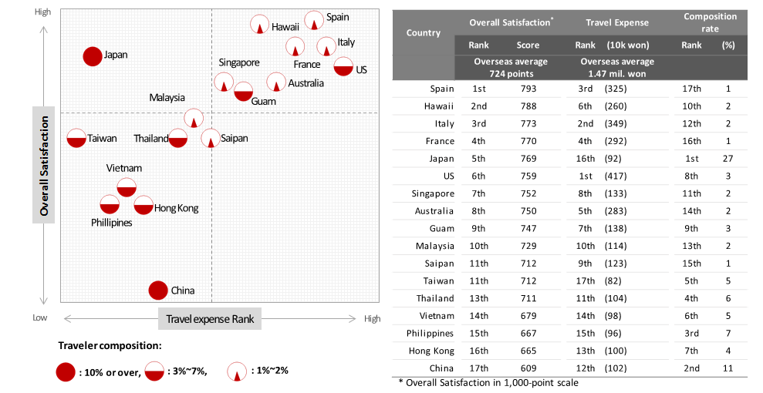
[Figure 1] Overall Satisfaction X Travel Expense of 17 Countries

□ Exception as cheap and satisfactory is Japan: There is an exceptional place with inexpensive travel expenses and high degree of satisfaction. The average cost per capita to Japan was 920k won, which was the 2nd least after Taiwan (820k won). Overall satisfaction was highly ranked at 5th with European three countries (Spain ∙ France ∙ Italy) and Hawaii on top of it. It is the highest travel destination in value for price. Japan was the place that had been selected by 27% of overseas travelers during the summer vacation period that was more than combining China ∙ Philippines ∙ Thailand (2nd ∙ 3rd ∙ 4th places).
Japan is an exceptionally successful country that draws the most of the travelers at low price, and make them satisfy. Flocking Koreans to there should have a good reason.

□ Big potential, Singapore & Taiwan: Singapore has advantages that are not inferior to Japan. It received the ratings that do not get behind of Japan at all in terms of travel resources and comfortableness. Cost is slightly higher (average 1.33 million won), but has unlimited potential.
Taiwan is an attractive travel destination in which you can enjoy average level of satisfaction (712 points) at the lowest cost (820k won). It is promising with the advantages of stress-free and not lacking resources.

□ Low priced package travel with many problems: Philippines, China & Vietnam were the low-cost regions as well as the lowest ranks in both experienced satisfaction and richness ∙ comfortableness aspects of travel resources. These countries are also the regions with high package travel rate. The low-priced package travel seemed to bring low level of satisfaction.

□ Travel destination comparison in major countries: The satisfactions of mostly visited major countries (Japan ∙ China ∙ Philippines ∙ Thailand ∙ Vietnam) by a lot of people as the travel destinations of summer vacation were compared by travel spot. Comparison within a country targeted only for the travel destinations with more than 30 samples, collecting five locations from Japan (Tokyo ∙ Okinawa ∙ Sapporo ∙ Osaka ∙ Fukuoka), four locations from China (Shanghai ∙ Beijing ∙ Shandong ∙ Hunan), 3 locations from Philippines (Cebu ∙ Boracay ∙ Manila), 3 locations from Thailand (Bangkok ∙ Pattaya ∙ Phuket) and 3 locations from Vietnam (Da Nang ∙ Hanoi ∙ Ho Chi Minh).

For each of the country, the travel destinations with highest rating in Overall satisfaction were Okinawa in Japan, Hunan in China, Boracay in Philippines, and Bangkok in Thailand and Da Nang in Vietnam. With the exception of Japan, they were all low ranked countries. But when you select these regions, it's possible to reduce the sense of disappointment.

<Table 2> The best travel destination by major country
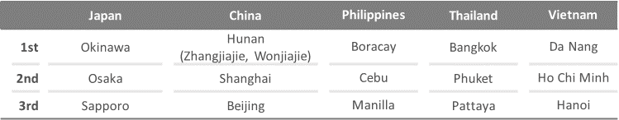

Japan is the best summer vacation place where the largest number of Korean people visit because of great sense of satisfaction at inexpensive price. With rich resources and stress-free comfortable environment, it has low package travel rate and the majority is filled with individual travel. It is necessary to benchmark how Japan had accommodated Korean travelers, made them satisfied and visited again.

----------------------------------------------------------------------------------------------------------------------------------------
Research and survey methods
Joint project of Sejong Tourism Industry Research Lab. ∙ Consumer Insights surveyed experience and evaluation on summer vacation travel for one or more nights between June to August. 800,000 IBP (Invitation Based Panel) of Consumer Insights was used as the sampling frame to survey 25,700 people, while sampling used proportional quota by gender ∙ age ∙ region according to the demographic ratio. Data collection used e-mail and mobile phone.
----------------------------------------------------------------------------------------------------------------------------------------
The press releases of Sejong Tourism Industry Research Lab. ∙ Consumer Trend Research Lab. of Consumer Insights are listed on the website (www.consumerinsight.kr/etravel)

Please contact the personnel in the below for detailed contents of this press release.
Cheif researcher /Ph.D, Kim, Min-Hwa kimmh@consumerinsight.kr
Senior researcher/Ph.D, Chung, Kyung-Sik jungks@consumerinsight.kr
Senior researcher/Ph.D, Moon, Ji-Hyo moonjh@consumerinsight.kr
* A part of or entire contents of this release cannot be used without written approval of releasing party *

